This is about how groups of people agree the objectives and behaviours that will help them support each other and achieve the best outcomes they can for themselves and their clients.

“Conflict in relationships is an inevitable feature of life - how we handle it remains one of the most important tasks facing humanity”

Nelson Mandella 2001 UN Speech (Attributed)

James Humes, President American Bar Assoc

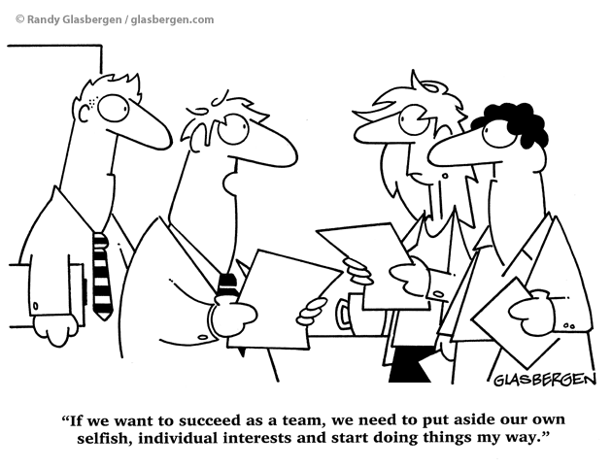

The Way We Work Together –

A Team Charter
Catalyst Mediation Training 2019©

Reference Manual

Background
People in organisations normally work together, either in groups of individual specialists or teams who are mutually dependant on the success of their projects.
They all spend more waking time with their work partners than they do with their life partners.
Yet frequently they don’t have the same sort of conversations that life partners do about how they will “live together”, what pleases and annoys them, what sort of behaviours they would expect of each other.
Which is where Team Charters or Value Charters come in.
As you will see these are simply a way for you to discuss and agree what goals and behaviours will make your working relationships 3E – Effective, Engaged and Enjoyable.
The examples below are just that – a starter for you to discuss, agree or disagree with, replace or add to. Once completed keep the Charter reference and to show to any future member of the team. It will help them understand what is expected of them and may spark some new ideas they can share.

What are Values?
“principles or standards of behaviour; one's judgement of what is important in life.
Oxford English Dictionery
Values in any relationship are the underpinning for the behaviours we want to see, would love to see and hate to see and in any relationship if you don’t know that your values are the same, then one of the most important values, trust, is probably missing.
What this document asks you to do is put down those values you think should be present, the behaviours that demonstrate the value and those which work against it and what you might expect if you do something that undermines the value – what you might call sanctions or restorative actions.
To give you an idea we have put Teamwork as the first value, together with some behaviours supporting and undermining it, together with possible sanctions.
You can add to or delete from the Teamwork examples, then move on to the other values we have found other people have put forward which we have put in as headings.
Finally if there are values you think should be in and we haven’t included them, please put them in.
We hope you find this an interesting starter exercise to understanding what behaviours are most important to you in a positive working relationship.
Kind regards

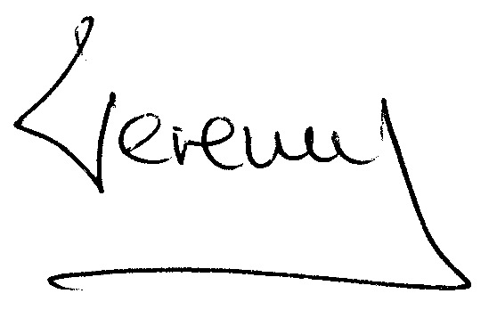

Jeremy Scuse
Managing Director

Catalyst Mediation Training

07733882543
Jeremy@catalystmediation.co.uk
www.catalystmediation.co.uk

Our Values

TEAM WORK

I demonstrate teamwork when I:
- Communicate openly and honestly
- Act to build and sustain team cohesion and performance
- Value the skills, capabilities and contribution of all team members
- Celebrate both individual and team achievements
- Share knowledge, information and skills with colleagues and staff
- Consider how my actions will affect others
- Acknowledge conflict and act to swiftly resolve it within the team
- Encourage others to grow and develop

I offend against the value of teamwork when I:
- Fail to behave as an multi-disciplinary team member
- Ignore input from others or devalue their contribution
- Do not share or pass on information in a timely fashion
- Hold grudges or resentments rather than act to resolve them
- Claim the praise and fail to acknowledge the contribution of others
- Neglect to thank others for their support and assistance
- Do not respect the roles and contributions of staff from all disciplines within the hospital or facility
- Act in a manner driven by self-interest

If I offend I should expect:
- My behaviour or language to be raised quickly by those affected.
- To listen respectfully to the impact I had on them.
- Apologise
- if appropriate and agree with them more suitable behaviours in future situations.

HONESTY
We take responsibility for our actions. We behave in a transparent manner, and reflect on our decisions and practices. We use our resources appropriately and uphold the public interest by being honest.

I demonstrate honesty when I:
- Am accountable for my words, decisions and actions
- Keep my commitments and promises

I offend against the value of honesty when I:
- Knowingly tell a lie or untruth
- Agree to do something when I have no intention of delivering

If I offend I should expect:
- My behaviour to be raised quickly by those affected.

RESPECT
We demonstrate that differences are accepted by ensuring that everyone gets to speak and be heard. We promote debate and discussion, and value the diverse views of our colleagues and communities. We deal with issues in a constructive and timely way.

I demonstrate respect when I:
- Acknowledge and value the experience and contribution of others
- Engage in discussion with others and listen to their views

I offend against the value of respect when I:
- Am inaccessible or unresponsive to answer questions, discuss issues or provide information
- Make independent decisions which affect others personally or their practice without consulting them

If I offend I should expect:
- My behaviour to be raised quickly by those affected.

EXCELLENCE
We demonstrate our commitment to providing high quality and innovative health care. We recognise and promote creativity, and support ongoing research and development. Our willingness to learn from our mistakes, and embrace change and innovation reflects our shared commitment to excellence.

I demonstrate excellence when I:
- Show commitment to high quality and innovative health care
- Personally model the Values Charter behaviours and encourage others to do likewise

I offend against the value of excellence when I:
- Do not personally model the Values

If I offend I should expect:
- My behaviour to be raised quickly by those affected.

EQUITY
We recognise and value the diversity of our staff and clients, respecting these differences and treating all people fairly and with dignity. We identify and address people’s needs, and we act in a fair and impartial manner in striving to meet these needs.

I demonstrate equity when I:
- Treat people fairly regardless of their background, discipline or position

I offend against the value of equity when I
- Dismiss or do not value different or opposing viewpoints

If I offend I should expect:
- My behaviour to be raised quickly by those affected.

COMMITMENT
We demonstrate our commitment to the community, our patients and the organisation by performing our jobs to the highest possible standards. We share responsibility for the identification of solutions, and we assist others to achieve their goals. We see setbacks as an opportunity for improvement, and acknowledge and promote the vision and mission of our organisation.

I demonstrate commitment when I:
- Support and champion the direction of the organisation

I offend against the value of commitment when I:
- Fail to verbally support the strategy and direction of the organisation

If I offend I should expect:
- My behaviour to be raised quickly by those affected.

COURAGE
We demonstrate courage by taking responsibility for our own actions. We acknowledge the challenging nature of the work we do, and identify and manage risk responsibly. We deal with problems and issues in a constructive way, and feel supported to resolve them. We confront inappropriate behaviour and practices.

I demonstrate courage when I:
- Am confident and willing to take managed risks

I offend against the value of courage when I:
- Avoid making difficult decisions

If I offend I should expect:
- My behaviour to be raised quickly by those affected.

Add any Other Values You Can Think Of:

